**Memo: Dynastic Democracies**

Table of Contents:

Table 1.2-1.3: Percent dynastic MPs by party and region 2

Figure: Map of India, Dynastic/non-Dynastic; Royal Dynastic/non-Dynastic 4

Figure: Map of India, Pre-Partition Princely States 5

Tables: Percent Dynastic MPs by type of constituency, gender, ethnicity 6

Table: Attributes and performance of dynastic/non-dynastic MPs 8

Graphs: Dynastic v non Dynastic MPs based on local rootedness, urban designation, marginal workers, and literacy rate 9

Graphs: Dynasticism by party 13

Figure: Maps of India, Dynastic/non Dynastic MPs that are females, SC/ST status 16

#### Table 1.2-1.3: Percent dynastic MPs by party and region

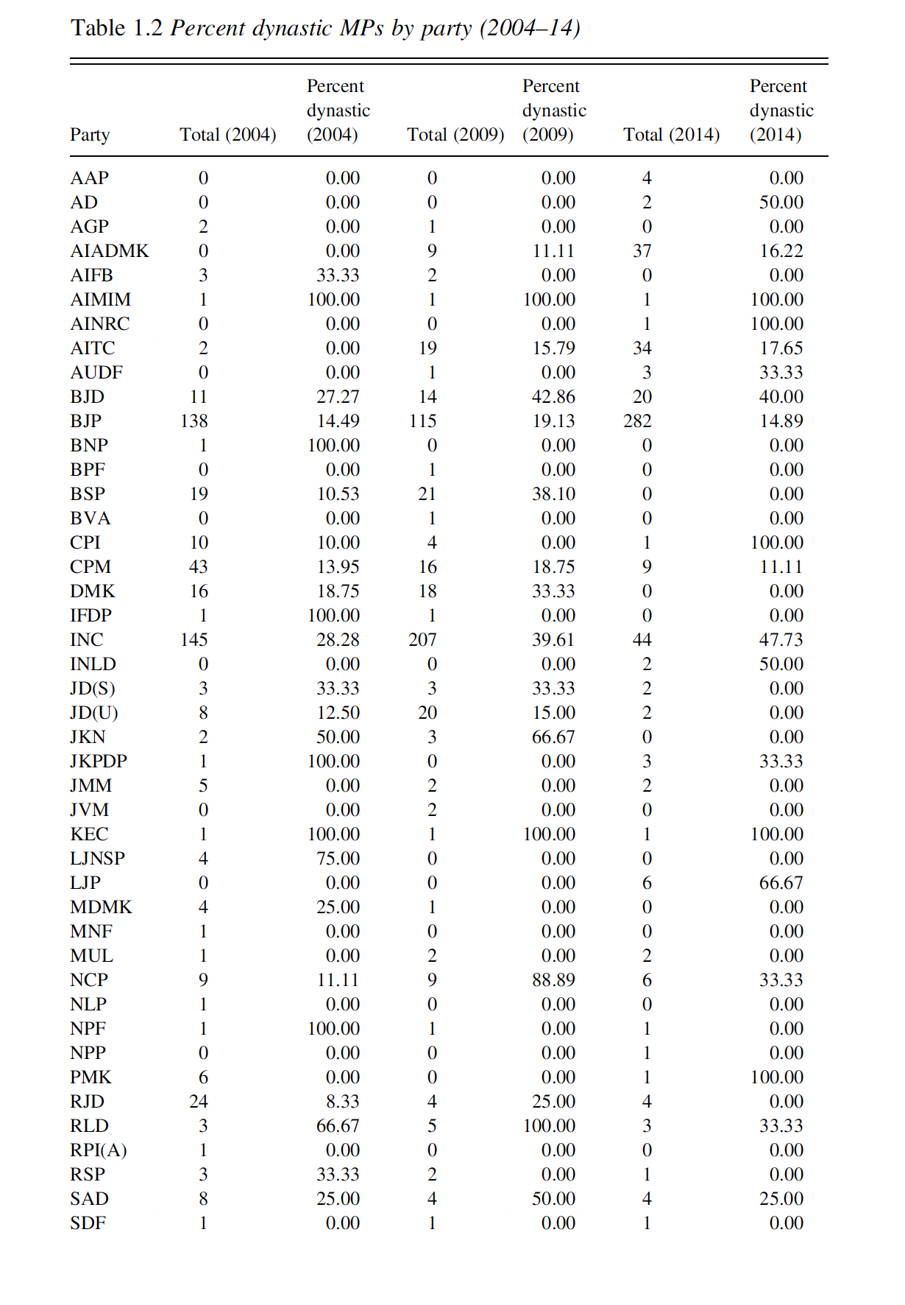

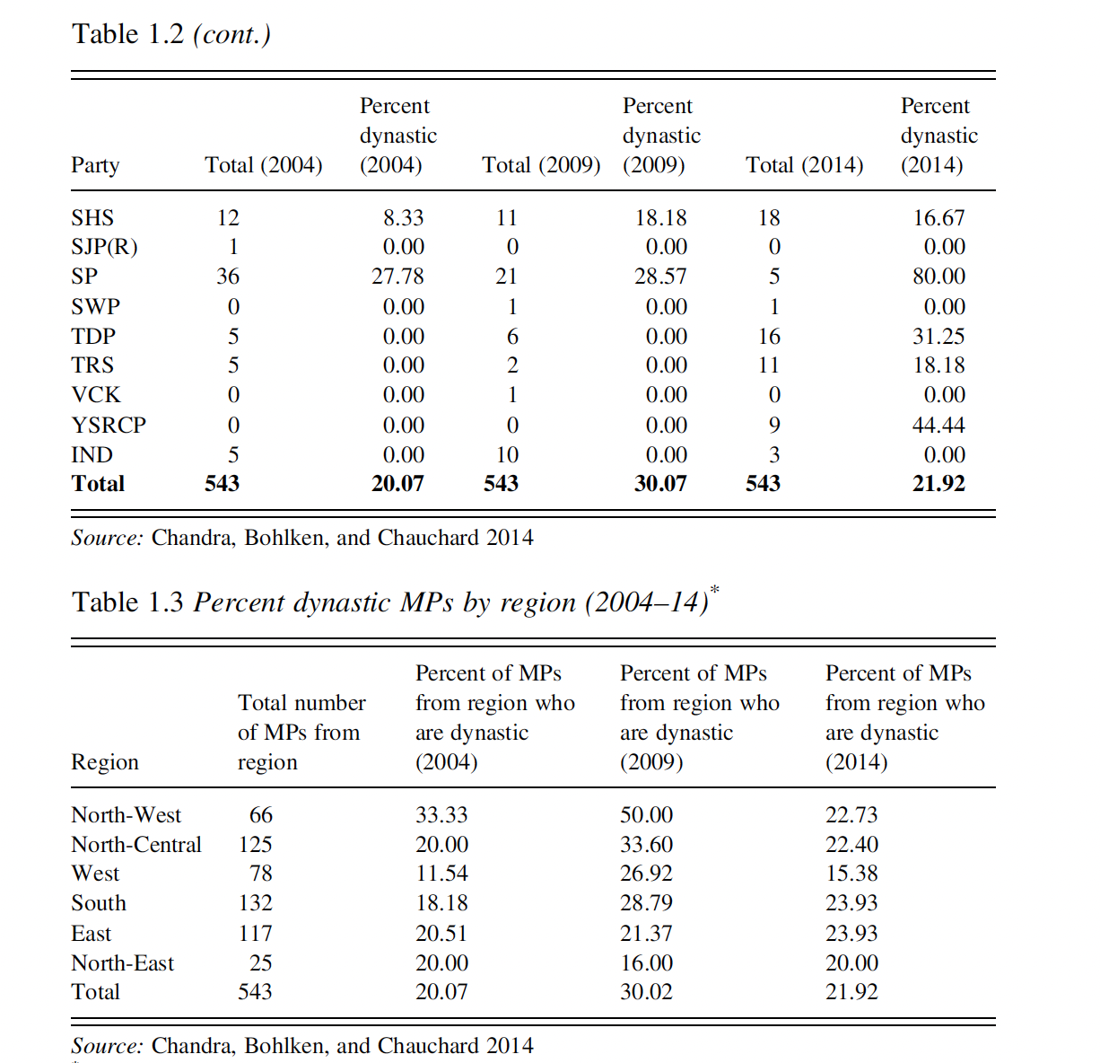

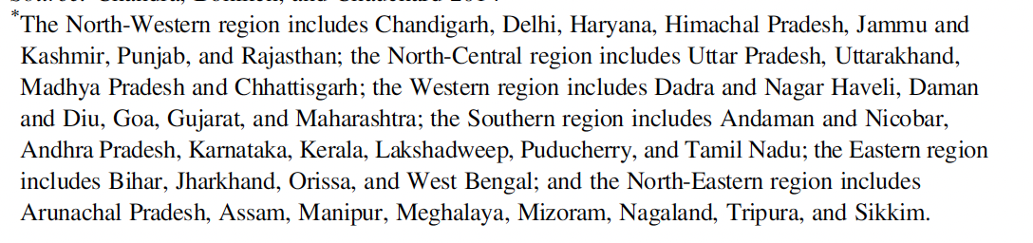

Pg 17, 18

#### Figure: Map of India, Dynastic/non-Dynastic; Royal Dynastic/non-Dynastic

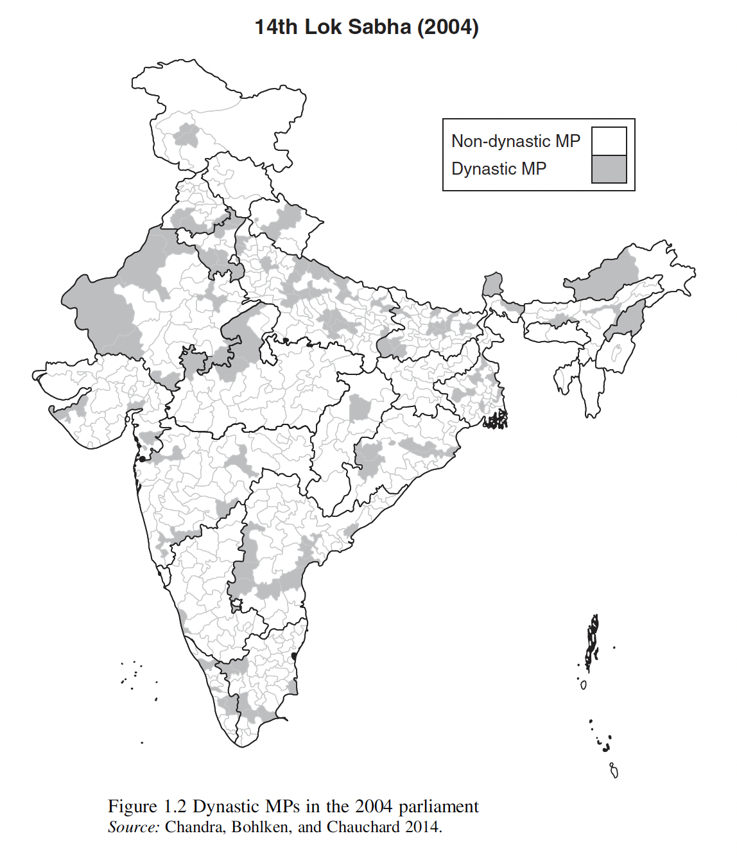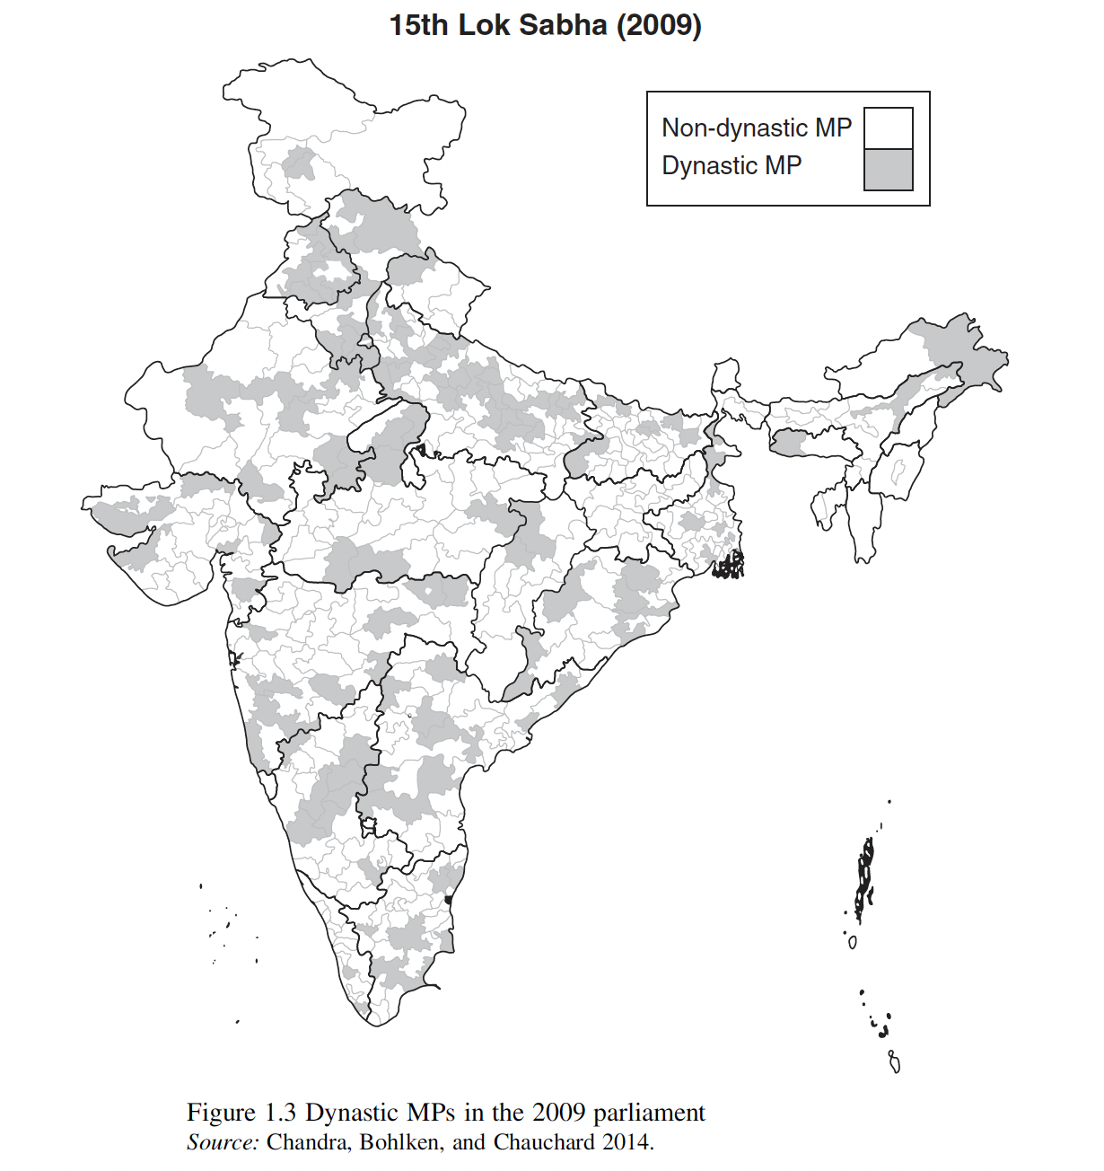

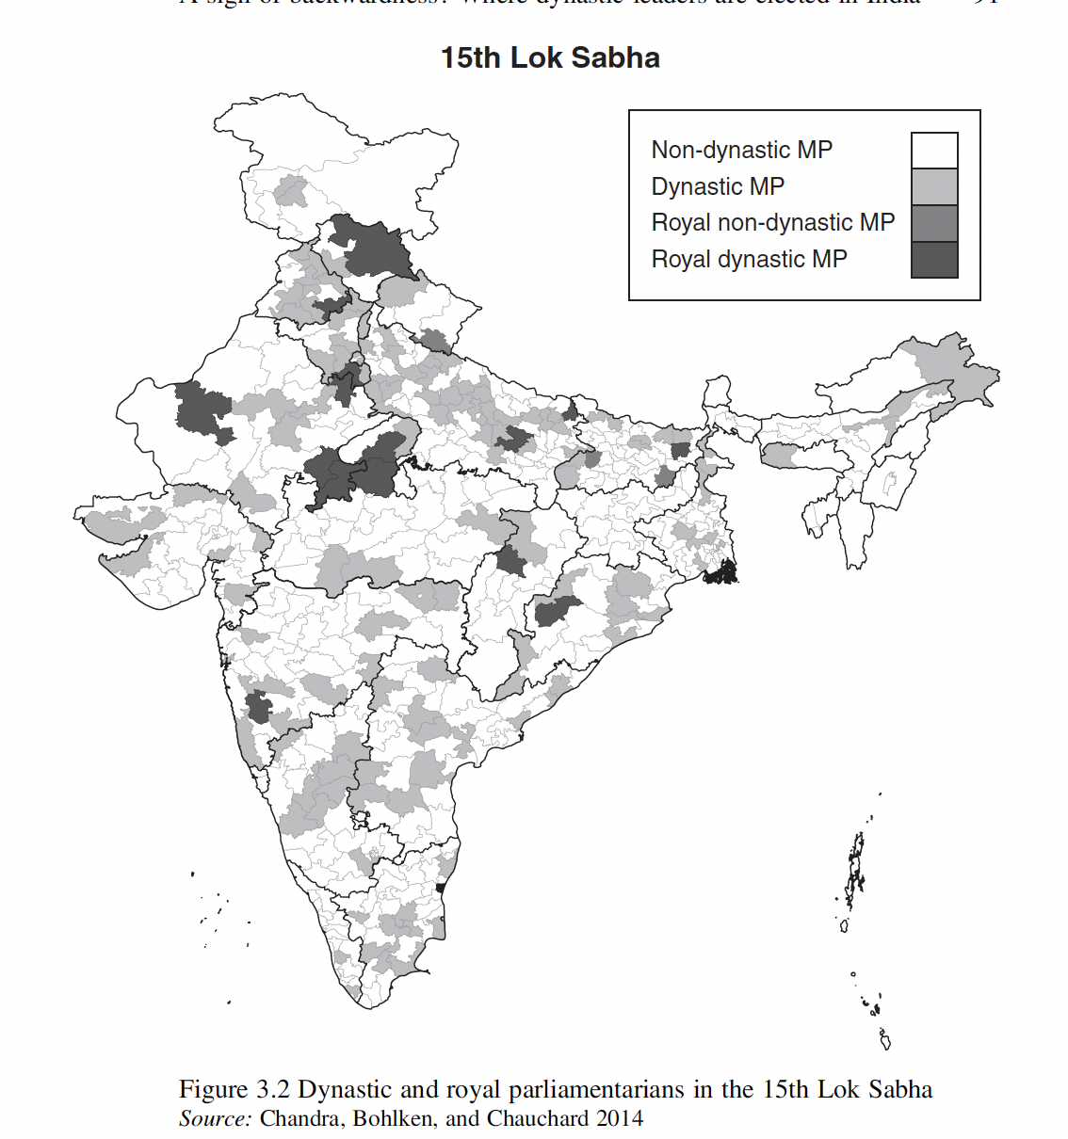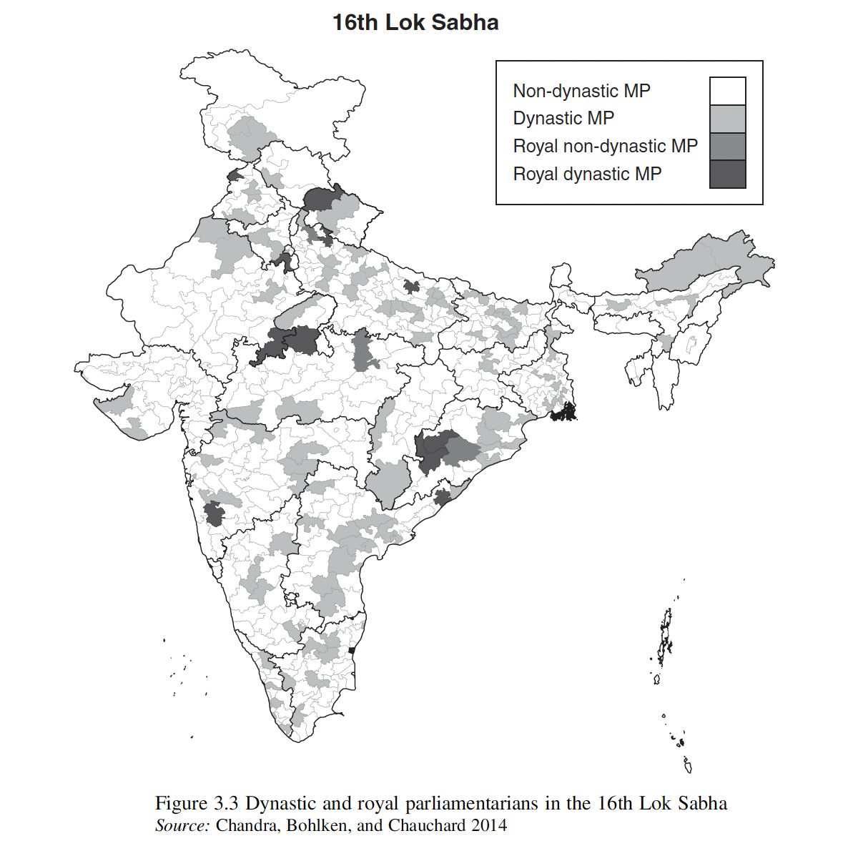

#### Figure: Map of India, Pre-Partition Princely States

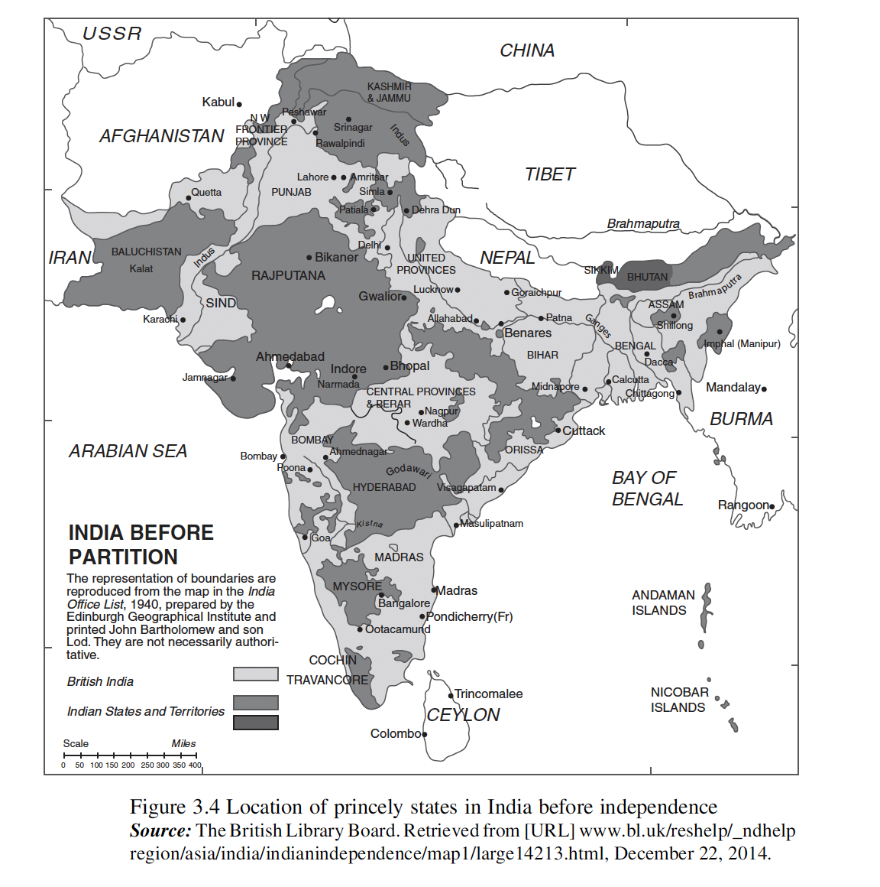

#### Tables: Percent Dynastic MPs by type of constituency, gender, ethnicity

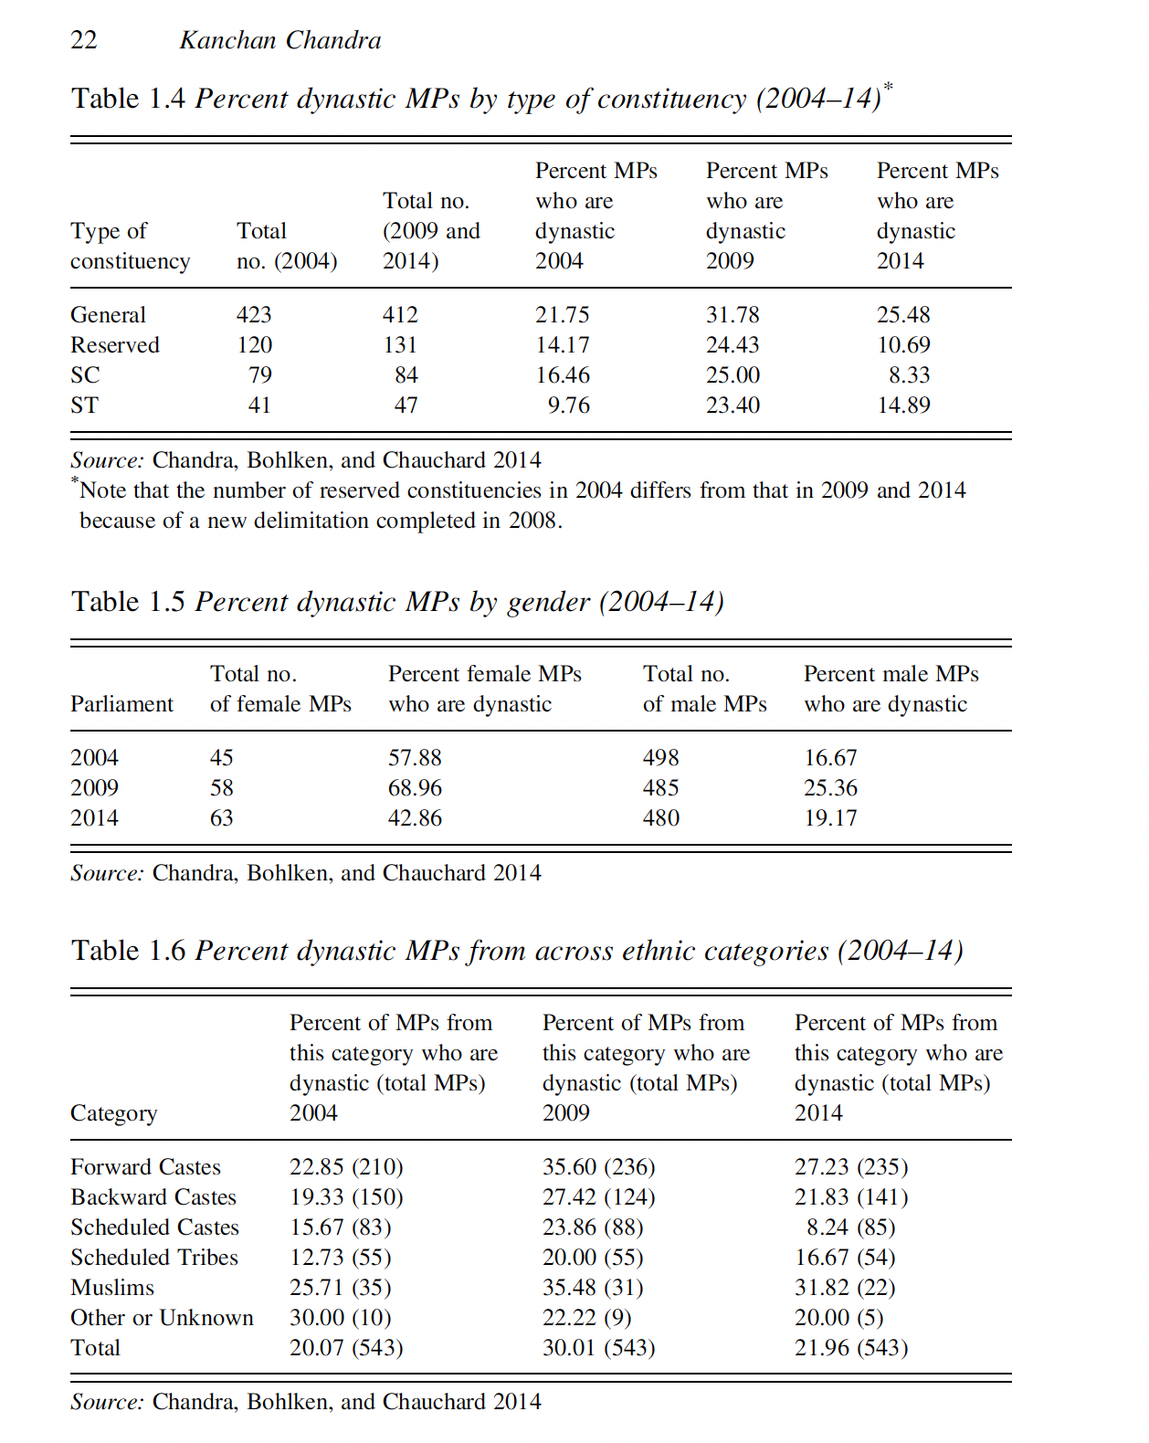

#### 

~~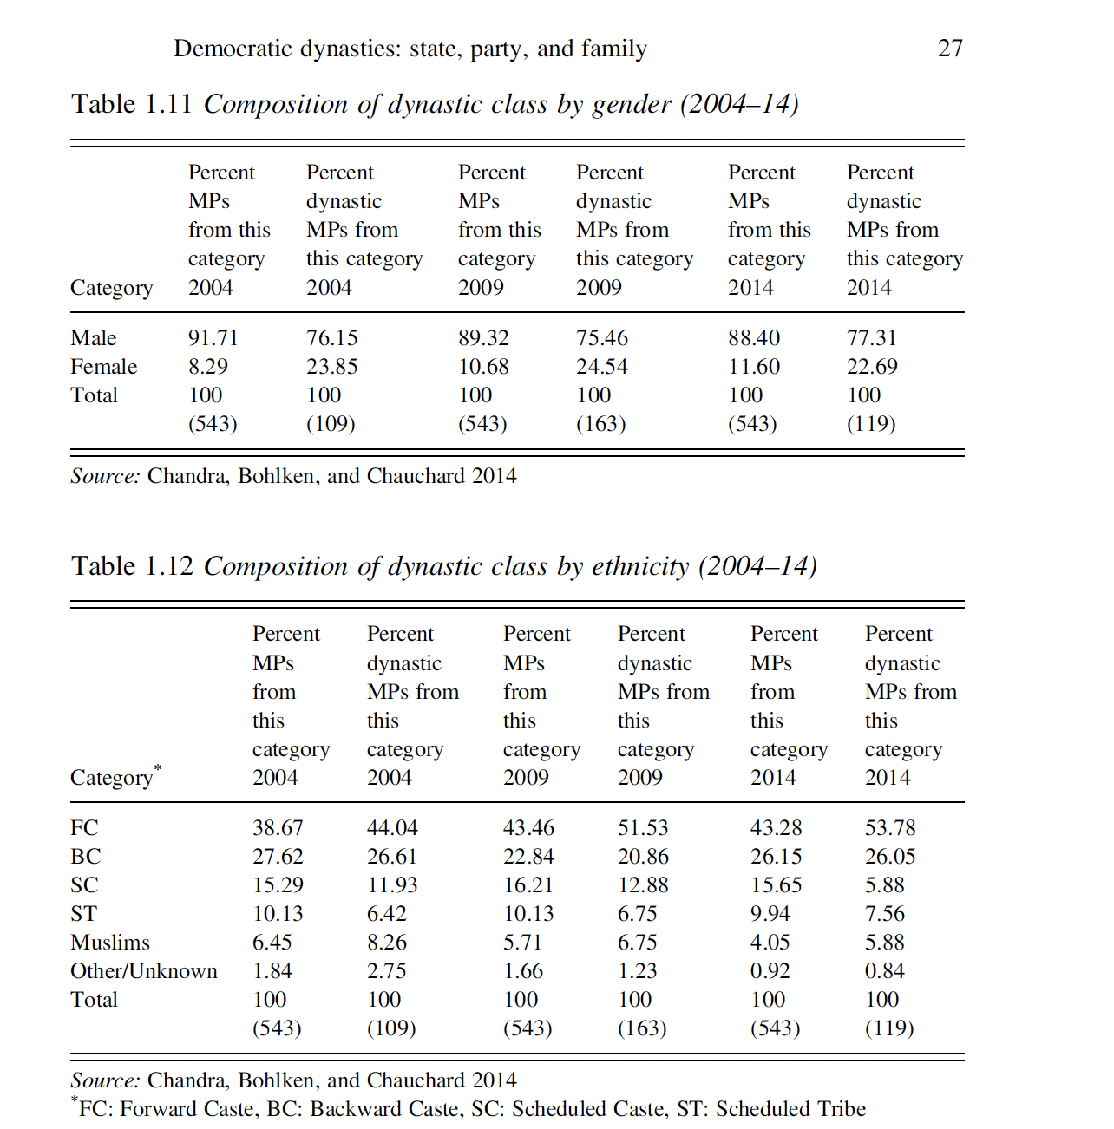~~

#### Table: Attributes and performance of dynastic/non-dynastic MPs

~~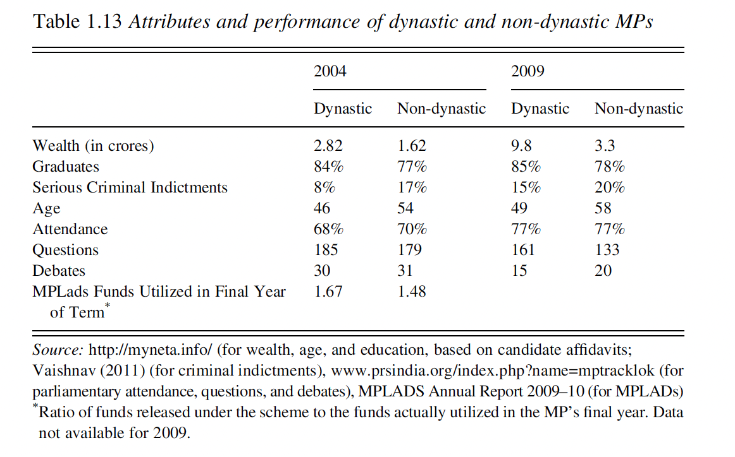~~

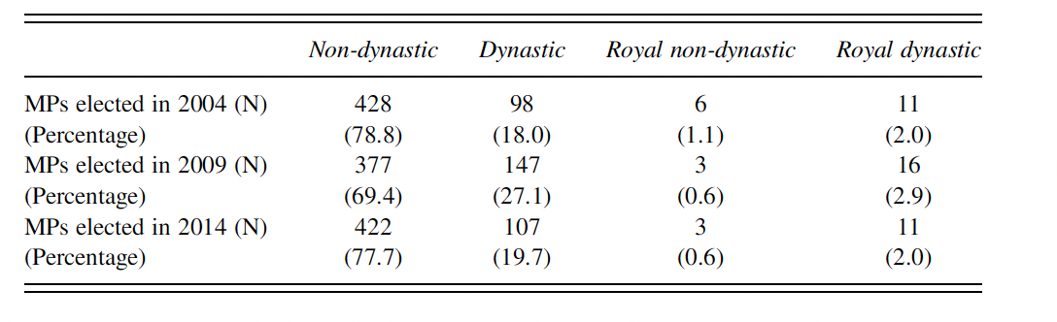

#### Graphs: Dynastic v non Dynastic MPs based on local rootedness, urban designation, marginal workers, and literacy rate

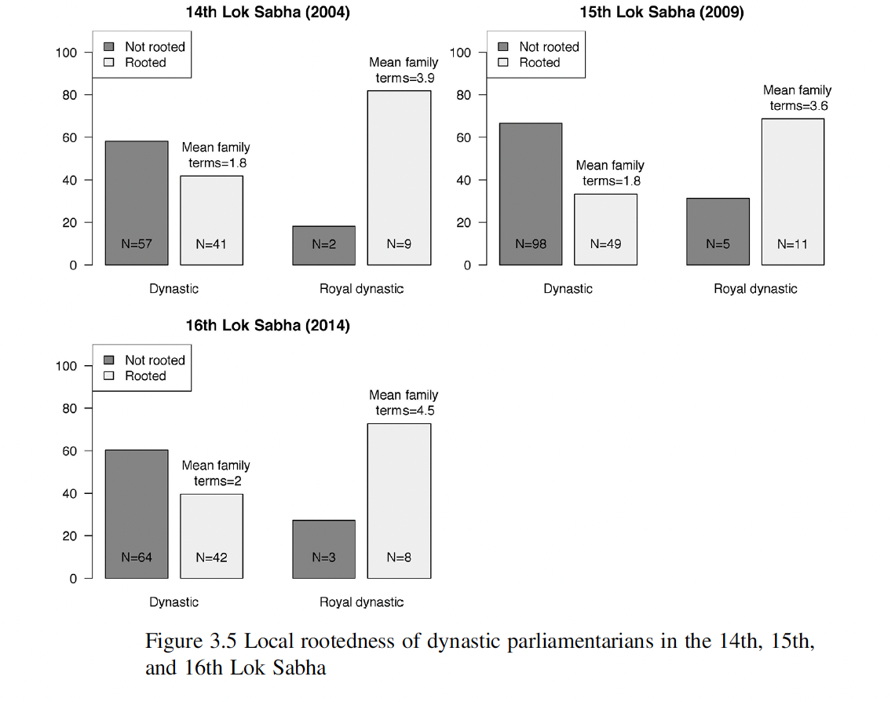

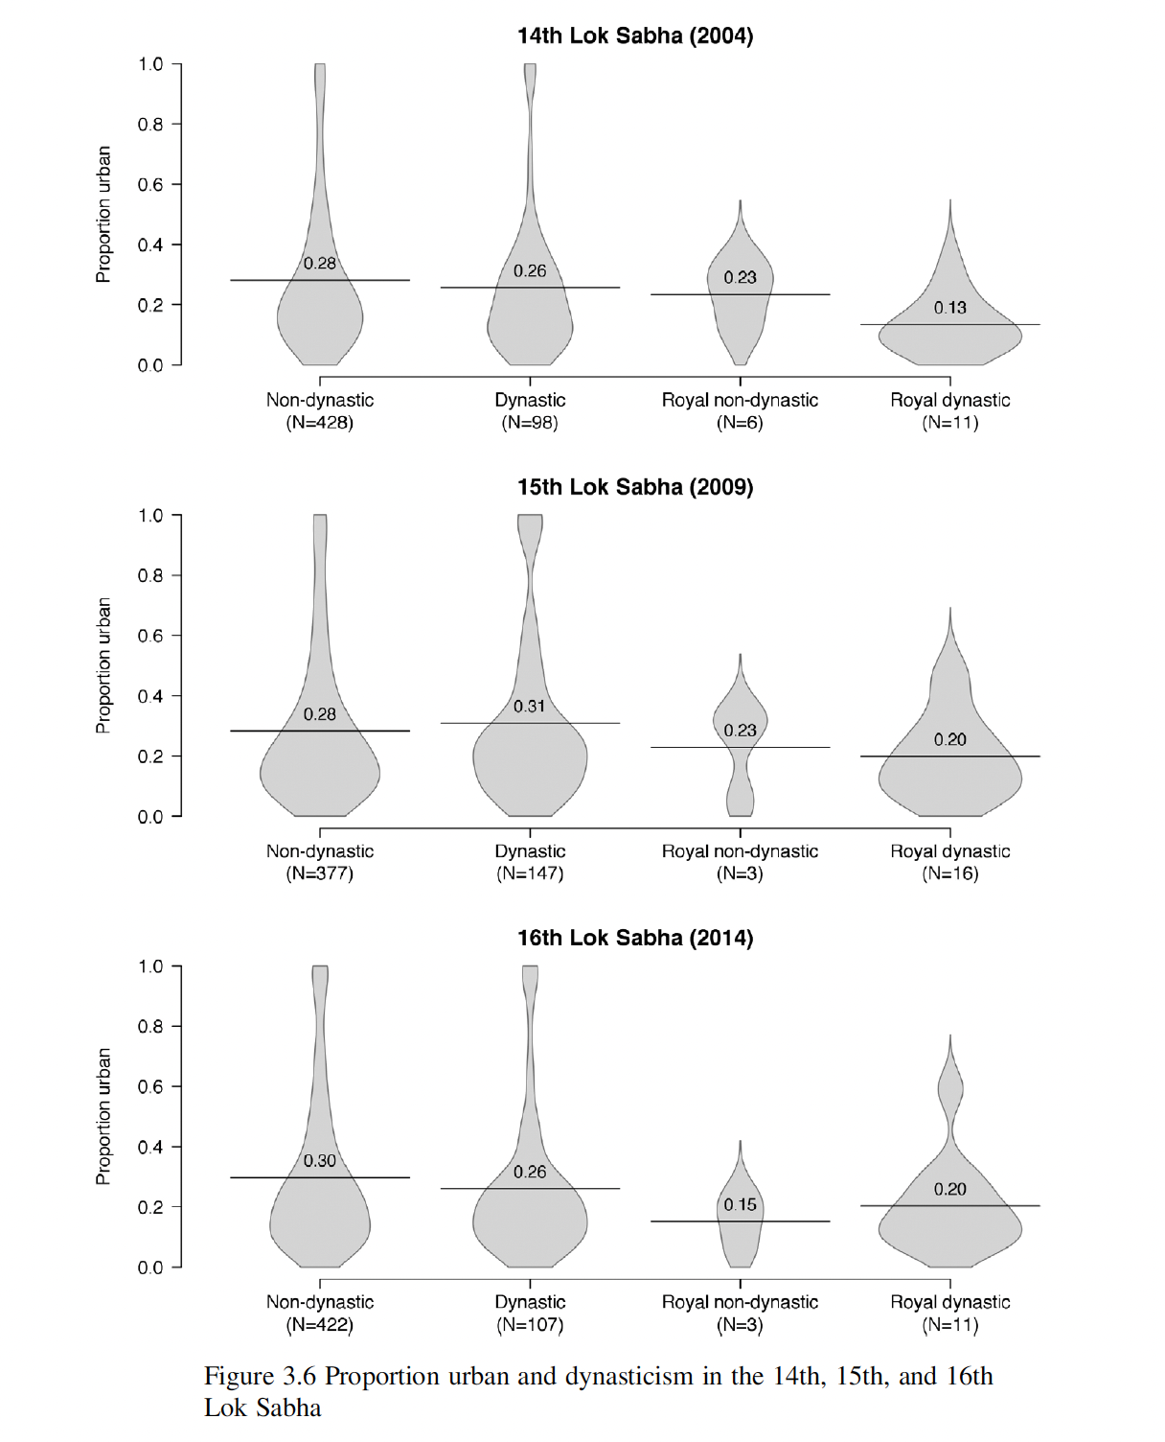

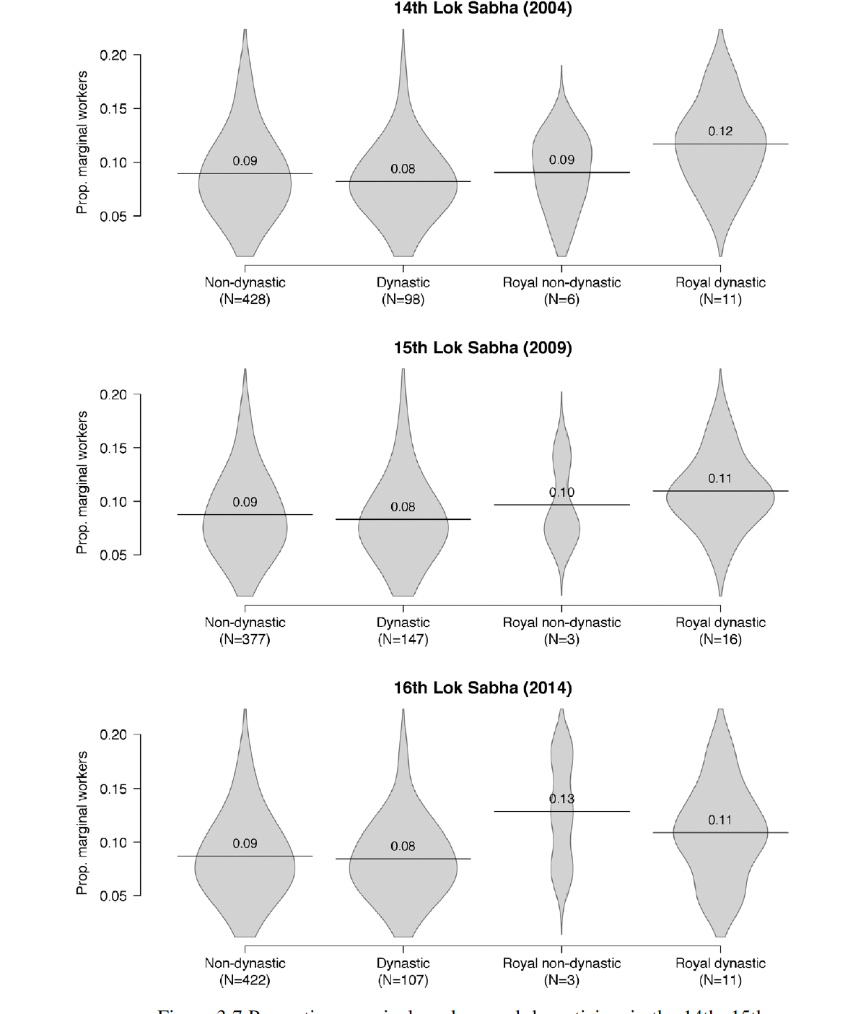

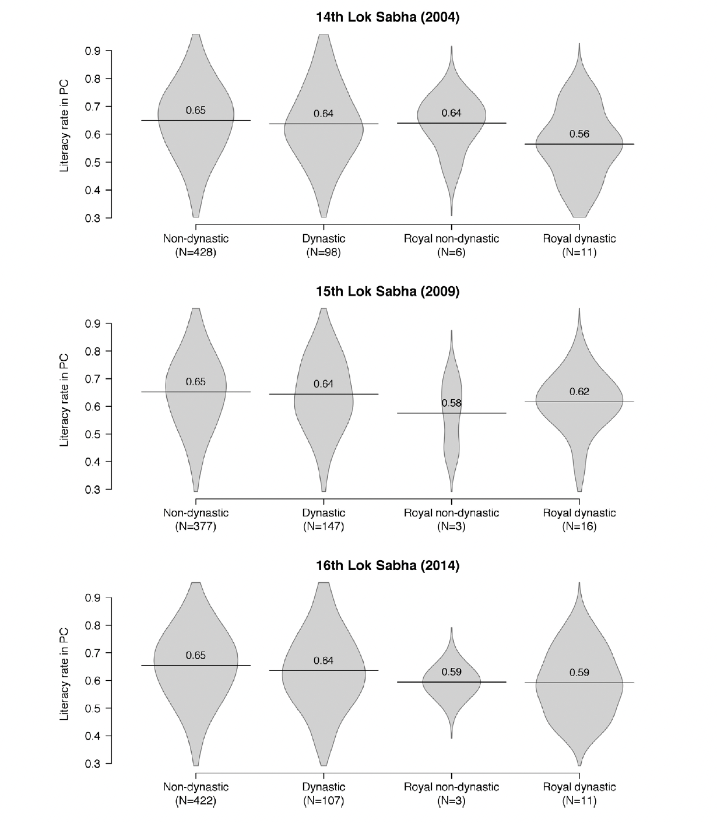

#### Graphs: Dynasticism by party

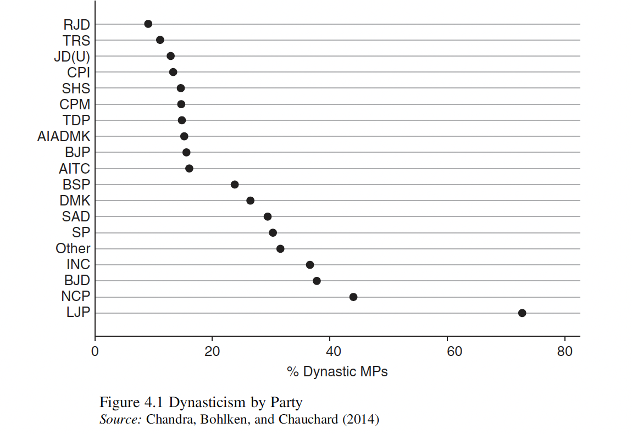

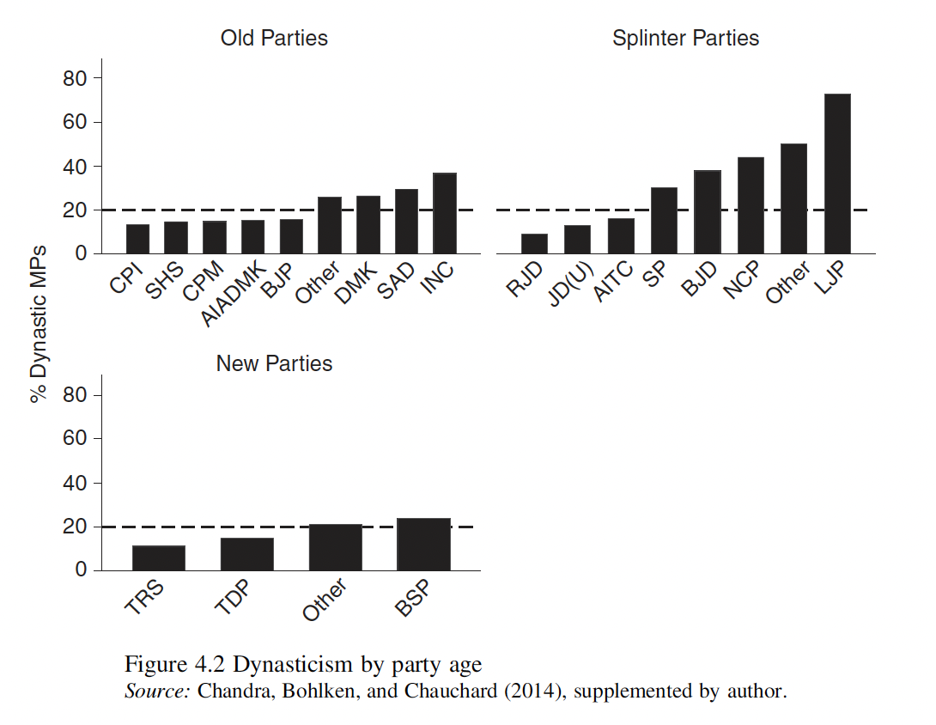

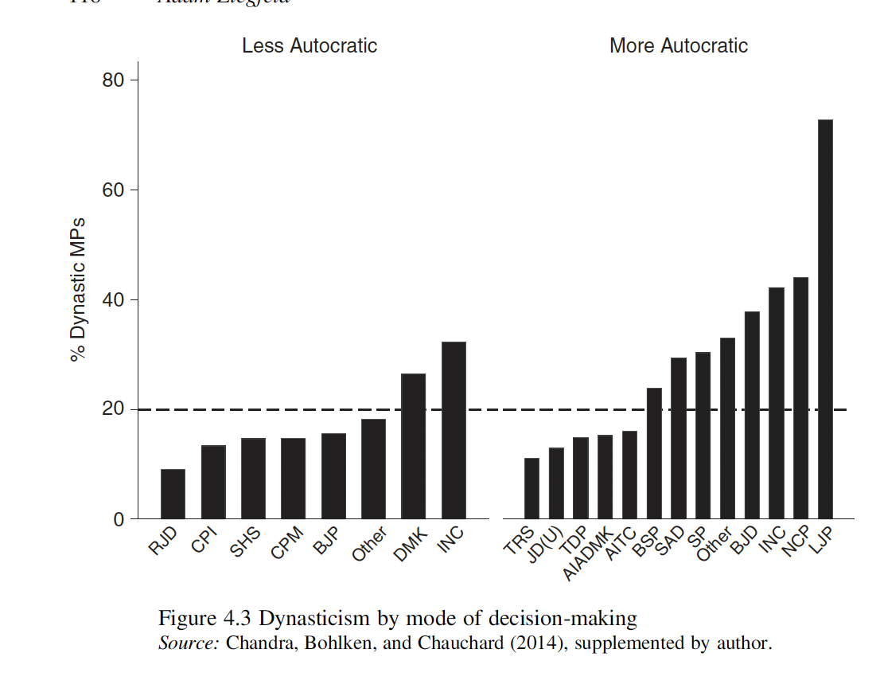

#### Figure: Maps of India, Dynastic/non Dynastic MPs that are females, SC/ST status

